AIM OF THE EXPERIMENT:-
To determine the percentage of various size particles in a soil sample, and to classify the coarse grained soil.
APPARATUS REQUIRED:-
- 1st set of sieves of size 300 mm, 80 mm, 40 mm, 20 mm, 10 mm, and 4.75 mm.
- 2nd set of sieves of sizes 2mm, 850 micron, 425 micron, 150 micron, and 75 micron.
- Balances of 0.1 g sensitivity, along with weights and weight box.
- Brush.
THEORY:-
Soils having particle larger than 0.075mm size are termed as coarse grained soils. In these soils more than 50% of the total material by mass is larger 75 micron. Coarse grained soil may have boulder, cobble, gravel and sand.
The following particle classification names are given depending on the size of the particle:
- BOULDER: particle size is more than 300mm.
- COBBLE: particle size in range 80mm to 300mm.
- GRAVE (G): particle size in range 4.75mm to 80mm.
- Coarse Gravel: 20 to 80mm.
- Fine Gravel: 4.75mm to 20mm.
- SAND (S): particle size in range 0.075mm to 4.75mm.
- Coarse sand: 2.0mm to 4.75mm
- Medium Sand: 0.075mm to 0.425mm.
- Fine Sand: 0.075mm to o.425mm.
Name of the soil is given depending on the maximum percentage of the above components.
Soils having less than 5% particle of size smaller than 0.075mm are designated by the symbols, Example:
GP: Poorly Graded Gravel.
GW: Well Graded Gravel.
SW: Well Graded Sand.
SP: Poorly Graded Sand.
Soils having greater than 12% of particle of size smaller than 0.075mm are designated by the following symbols:
Dual symbols are used for the soils having 75 micron passing between 5 to 12%.
Dry sieve is performed for cohesion less soils if fines are less than 5%. Wet sieve analysis is carried out if fines are more than 5% and of cohesive nature.
We can analysis from foiling,
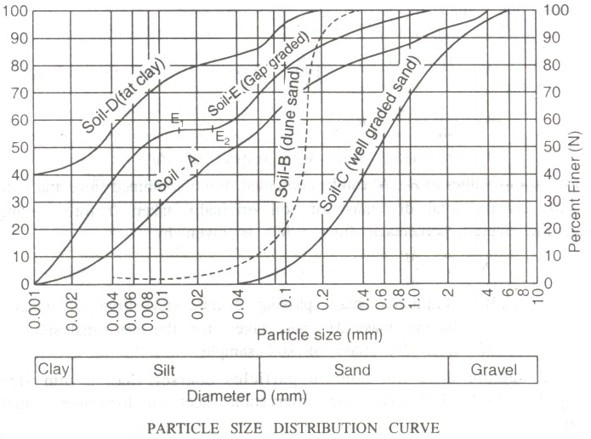
In simpler way we can show the above particle size distribution curve for course grain soil as fallows,
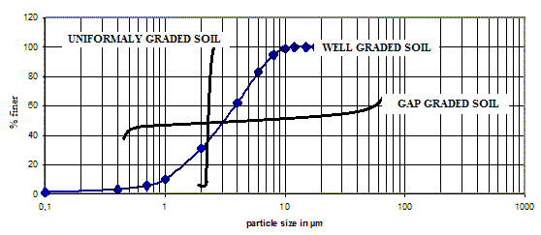
Gravels and sands may be either poorly graded (Uniformly graded) or well graded depending on the value of coefficient of curvature and uniformity coefficient.
Coefficient of curvature (C_{c}) may be estimated as:
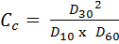
Coefficient of curvature (C_{c}) should lie between 1 and 3 for well grade gravel and sand.
Uniformity coefficient (C_{u}) is given by:
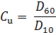
Its value should be more than 4 for well graded gravel and more than 6 for well graded sand.
Were, D₆₀ = particle size at 60% finer.
D₃₀ = particle size at 30% finer.
D₁₀ = particle size at 10% finer.

FIGURES:
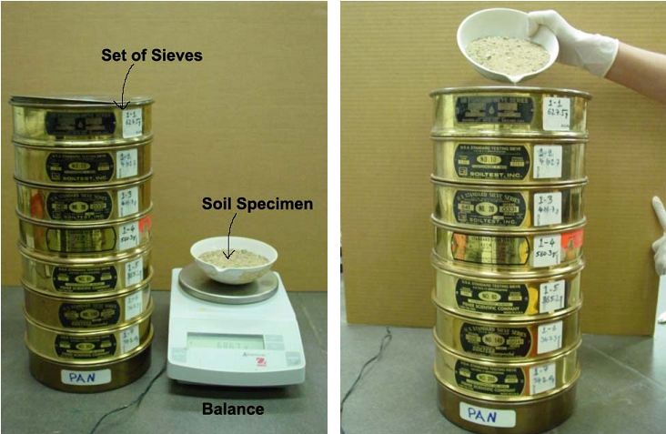
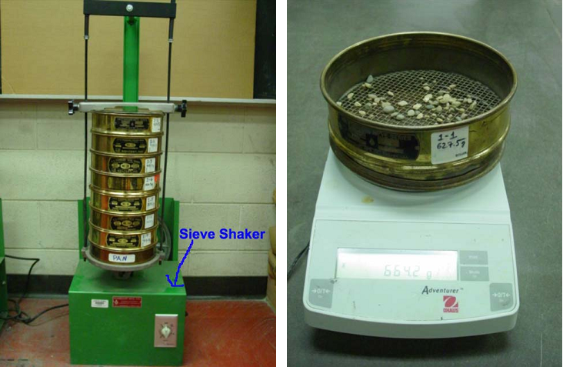

APPLICATION:
The percentage of different size of soil particles coarser than 75 micron is determined. Coarse soils are mainly classified by sieve analysis. The grain size distribution curve gives an idea regarding the gradation of the soil, that is, it is possible to identify whether the soil is well graded or poorly graded. In mechanical soil stabilization, the main principle is to mix a few selected soils in such a proportion that a desired grain size distribution is obtained for the design mix. Hence for proportioning the selected soils, the grain size distribution of each soil is to be first known.
PROCEDURE:
- Weight accurately about 200gms of oven dried soil sample. If the soil has a large fraction greater than 4.75mm size, then greater quantity of soil, that is, about 5.0 Kg should be taken. For soil containing some particle greater than 4.75 mm size, the weight of the soil sample for grain size analysis should be taken as 0.5 Kg to 1.0 Kg.
- Clean the sieves and pan with brush and weigh them upto 0.1 gm accuracy. Arrange the sieves in the order as shown in Table. The first set shall consist of sieves of size 300 mm, 80mm, 40mm, 20mm, 10mm, and 4.75 mm. While the second set shall consist of sieves of sizes 2mm, 850 micron, 425 micron, 150 micron, and 75 micron.
- Keep the required quantity of soil sample on the top sieve and shake it with mechanical sieve shaker for about 5 to 10 minutes. Care should be taken to tightly fit the lid cover on the top sieve.
- After shaking the soil on the sieve shaker, weigh the soil retained on each sieve. The sum of the retained soil must tally with the original weight of soil taken.

DATA ANALYSIS:
- Obtain the mass of soil retained on each sieve by subtracting the weight of the empty sieve from the mass of the sieve + retained soil, and record this mass as the weight retained on the data sheet. The sum of these retained masses should be approximately equals the initial mass of the soil sample. A loss of more than two percent is unsatisfactory.
- Calculate the percent retained on each sieve by dividing the weight retained on each sieve by the original sample mass.
- Calculate the percent passing (or percent finer) by starting with 100 percent and subtracting the percent retained on each sieve as a cumulative procedure.
For example: Total mass = 500 g
Mass retained on No. 4 sieve = 9.7 g
Mass retained on No. 10 sieve = 39.5 g
For the No.4 sieve:
Quantity passing = Total mass - Mass retained
= 500 - 9.7 = 490.3 g
The percent retained is calculated as;
% retained = Mass retained/Total mass
= (9.7/500) X 100 = 1.9 %
From this, the % passing = 100 - 1.9 = 98.1 %
For the No. 10 sieve:
Quantity passing = Mass arriving - Mass retained
= 490.3 - 39.5 = 450.8 g
% Retained = (39.5/500) X 100 = 7.9 %
% Passing = 100 - 1.9 - 7.9 = 90.2 %
(Alternatively, use % passing = % Arriving - % Retained
For No. 10 sieve = 98.1 - 7.9 = 90.2 %)
- Make a semilogarithmic plot of grain size vs. percent finer.
- Compute C_{u} and C_{c} for the soil.
PRECAUTIONS:
- During shaking the lid on the topmost sieve should be kept tight to prevent escape of soils.
- While drying the soil, the temperature of the oven should not be more than 105 c because higher temperature may cause some permanent change in the 75 fraction.
OBSERVATION AND CALCULATION TABLE:
Mass of soil Sample taken for Analysis = M____
Sieve size  (mm) | Mass of soil Retained (gms) | % of soil retained (%)  =(x/M) | Cumulative % of soil retained (%) | % finer  =(100 – p)
80 | x1 | y1 | p1=y1 | n1=100-p1
40 | x2 | y2 | p2=y1+y2 | n2=100-p2
20 | x3 | y3 | p3=y1+y2+y3+.... | n3=100=p3
10
4.75
2.0
0.850
0.425
0.150
0.075
pan

Coefficient of curvature (C_{c}) may be estimated as:
Uniformity coefficient (C_{u}) is given by:

Example 1:
Weight of Container: 198.5 gm
Wt. Container + Dry Soil: 722.3 gm
Wt. of Dry Sample: 523.8 gm
Sieve Number | Diameter (mm) | Mass of Empty Sieve (gm) | Mass of Sieve + Soil Retained (gm) | Soil retained (gm) | Percent Retained | Percent Passing
4 | 4.75 | 116.23 | 166.13 | 49.9 | 9.5 | 90.5
10 | 2 | 99.27 | 135.77 | 36.5 | 7 | 83.5
20 | 0.84 | 97.58 | 139.68 | 42.1 | 8 | 75.5
40 | 0.425 | 98.96 | 138.96 | 40 | 7.6 | 67.8
60 | 0.25 | 91.46 | 114.46 | 23 | 4.4 | 63.4
140 | 0.106 | 93.15 | 184.15 | 91 | 17.4 | 46.1
200 | 0.075 | 90.92 | 101.12 | 10.2 | 1.9 | 44.1
Pan | --- | 70.19 | 301.19 | 231 | 44.1 | 0
Total Weight |  |  |  | 523.7

*Percent passing=100-cumulative percent retained.
From Grain Size Distribution Curve:
% Gravel = 9.5 D₁₀ = 0.002 mm
% Sand = 46.4 D₃₀ = 0.017 mm
% Fines = 44.1 D₆₀ = 0.25 mm
C_{u} = 0.25/0.002 = 125
C_{c}= (0.017)² / (0.025 x 0.002) = 0.58
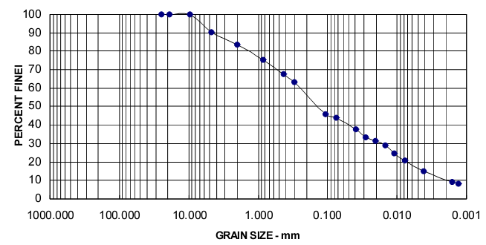
QUESTIONNAIRE:
- What do you understand by well graded, poorly graded and uniformly graded soils?
- What do you understand by dry sieve and wet sieve analysis? Which once did you perform and why?
- What is the grain size distribution curve? Why do you use a semi-long graph paper for plotting it?
- What do you understand by GW,GP,GM,GC,SW,SP,SM,SC,SW-SM,GP-SC?
- Sonic sieving is used for coarse type of soils (True/ False)
- A dense gradation will result in an _____ curve on the gradation graph (Even, Steep, Horizontal, vertical)
- The results of Sieve analysis are generally presented by semi-logarithmic plots known as --------- (Particle size distribution cure, Fines ness distribution curve)

PART – 2
ANIMATION STEPS

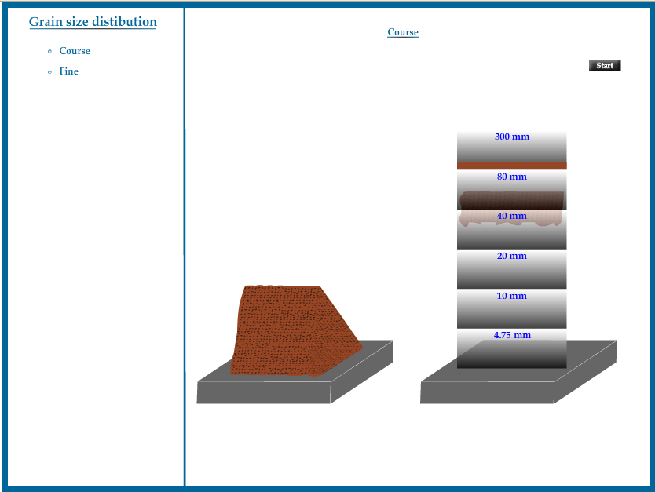

PART – 3
VIRTUAL LAB FRAME
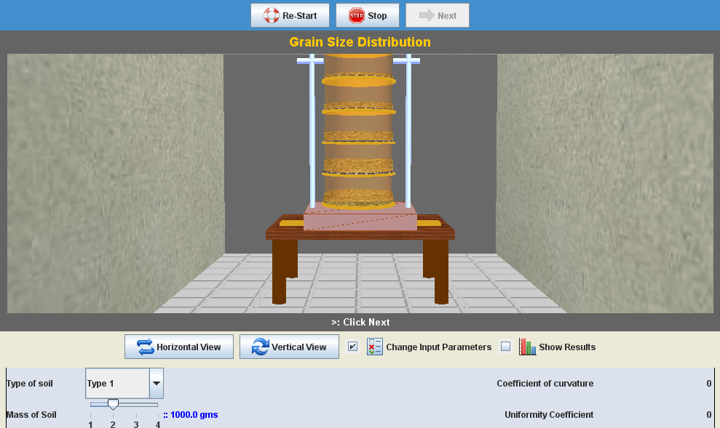
LABORATORY ROOM CONSISTS:
- Table
- Different Sieve sizes
- Shaker
- Weight Balance

INPUT:
- Type of Soil
- Weight of Sample Soil

OUTPUT:
- Grading of Soil

Example Graphs:
Well Graded
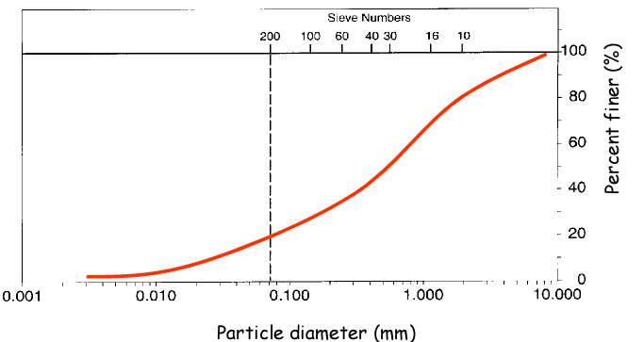

Uniformly Graded
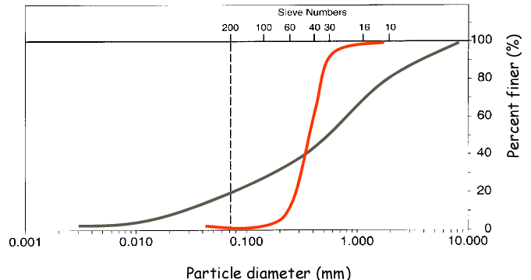

Gap Graded
